Demo video:
In this video I have showed the project demo by running our code file that is provided in the zip file.
The video is made through steve AI but all the editing and script is of fine. If u will watch this video I will feel my hard work of 5-6 hrs was successful
Demo video –https://drive.google.com/file/d/13b9K8y84Dww12Gfa_658w9gw24w6wM7M/view?usp=sharing

**Ensure that u have selected max quality for not blurred text.
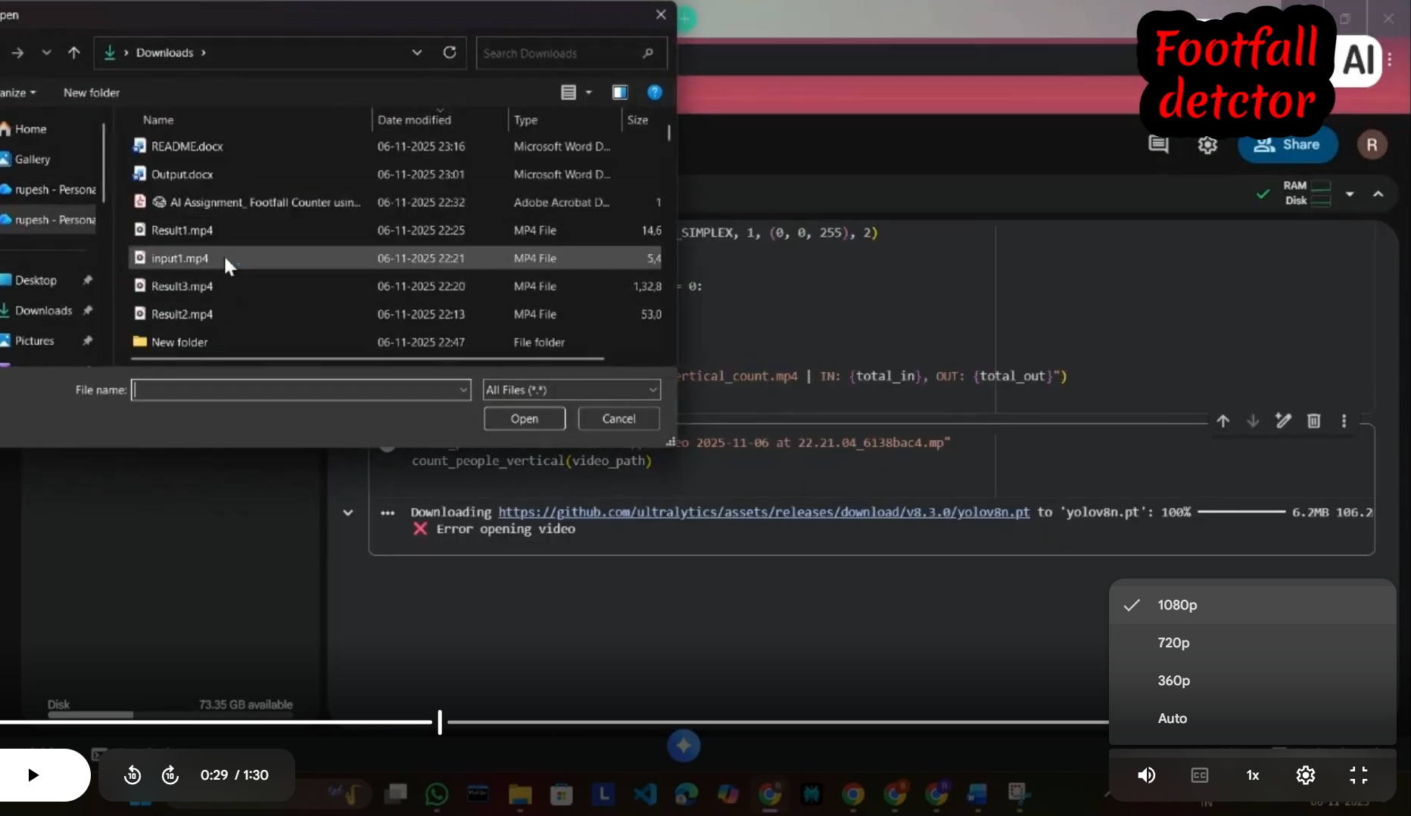

Again thanks for giving me this opportunity .
Rupesh(Aspiring AI & ML engineer)
Palwal,Haryana

